03/04 – I received the Raspberry Pi from one of my members.

03/05 – I began working on the ARM Assembly portion of the assignment. I had to familiarize myself with the Raspberry Pi first. I did this by figuring out how to take screenshots using Scrot, where to save them, what commands to use in the terminal and gdb, etc.

03/06 – I formally began on the assignment.

**PART 1:**

*What error messages did you get and why?*

The screen reported the following error message:

Error: unknown pseudo-op: ‘.shalfword’

This error message is due to the use an incorrect data representation in the program. I corrected this error by changing “.shalfword” to “.hword”

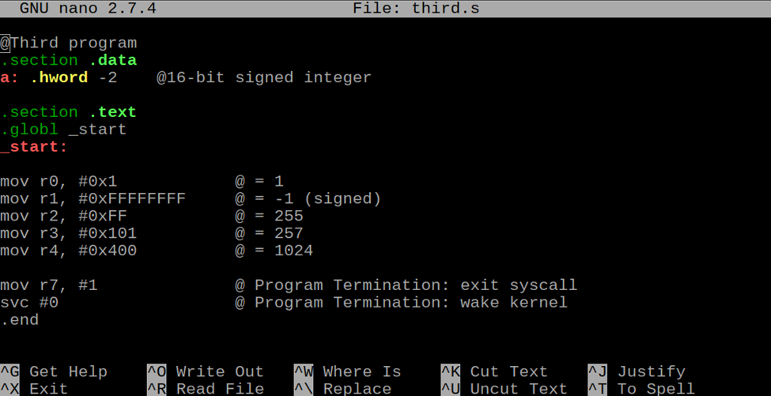

I debugged the program using GDB. I first used list to display the code then I set a breakpoint and used the run command to begin stepping through the program. I used “p &a” to retrieve the address of the halfword integer. As per the assignment instructions, I used the “x” command to examine the memory. I did this for h and sh.

**PART 2:**

For part two, I created a constant for val1, val2, and val3 in the .data portion of the program. In order to use the constant values, I used ldr to load the values into memory. For unsigned bytes, I used ldrb and for signed bytes, I used ldrsb. I then completed the arithmetic without issue.

I used GDB again to step through the program and check the registers for the ending values. The cpsr shows that a flag was raised.

